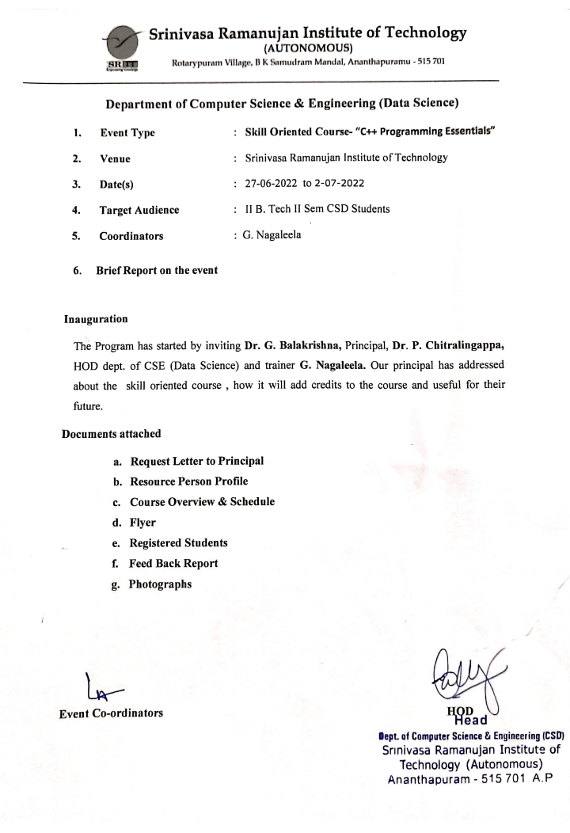

1. Request Letter to Principal

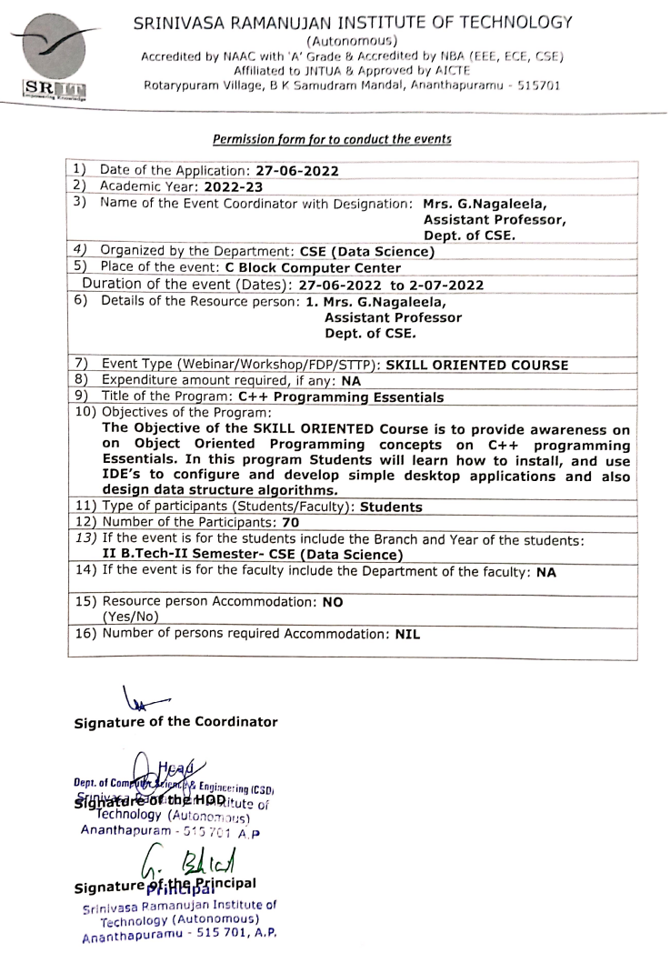

**b. Resource Persons Profile:**

**Title of the Even**t **: “CCNAV7: Introduction to Networks”**

## No of Participants : 72

## Dates : 05-06-2023 to 09-06-2023

# About Resource(s) Person:

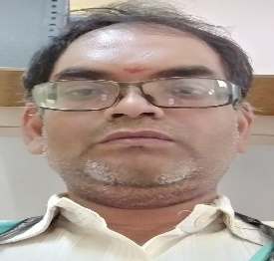 **Mr. M. Narasimhulu M.Tech** working as Assistant Professorin Computer Science and Department at Srinivasa Rumanian Institute of Technology, Anatapuramu**.** He has experience of 17yearsin teaching profession and participated various FDP and training Programs. He completed NPTEL, EDU skill Certification Programs for the past 17 Years. He trained one SOC Program in Association Cisco Network Academy. He also trained Several Cisco Programs Since 2020.

**C: Course Overview & Schedule:**

Welcome to the **Introduction to Networks (ITN) course**. This course introduces the architecture, structure, functions, components, and models of the Internet and other computer networks. The principles and structure of IP addressing and the fundamentals of Ethernet concepts, media, and operations are introduced to provide a foundation for the curriculum. By the end of the course, students will be able to build simple local area networks (LAN), perform basic configurations for routers and switches, and implement IP addressing schemes.

**Specific objective of Training:**

* Build simple LANs, perform basic configurations for routers and switches, and implement IPv4 and IPv6 addressing schemes.
* Configure routers, switches, and end devices to provide access to local and remote network resources and to enable end-to-end connectivity between remote devices.
* Develop critical thinking and problem-solving skills using real equipment and Cisco Packet Tracer.
* Configure and troubleshoot connectivity a small network using security best practices.

**CCNAv7: Introduction to Networks:**

**Module 1: Networking Today**

Introduction, Networks Affect our Lives, Network Components, Network Representations and Topologies, Common types of Networks, Internet Connections, Reliable Networks, Network Trends, Network Security, The IT Professional.

**Module 2: Basic Switch and End Device Configuration**

Introduction, Cisco IOS Access, IOS Navigation, Command Structure, Basic Device Configuration,

Save Configuration, Ports and Address, Configure IP Addressing, Verify Connectivity.

**Module 3: Protocols and Models**

Introduction, The Rules, Protocols, Protocol Suites, Standard Organization, Reference Models, Data Encapsulation, Data Access.

**Module 4: Physical Layer**

Introduction, Purpose of the Physical Layer, Physical Layer Characteristics, Copper Cabling, UTP Cabling, Fiber-Optic, Wireless Media.

**Module 5: Number Systems**

Introduction, Binary Number System, Hexadecimal Number System.

**Module 6: Data Link Layer**

Introduction, Purpose of the Data Link Layer, Topologies, Data Link Frame.

**Module 7: Ethernet Switching**

Introduction, Ethernet Frames, Ethernet MAC Address, The MAC Address Table, Switch and Forwarding Methods.

**Module 8: Network Layer**

Introduction, Network Layer Characteristics, IPV4 Packet, IPV6 Packet, How a Host Routes, Introduction to Routing.

**Module 9: Address Resolution**

Introduction, MAC and IP, ARP, IPv6 Neighbor Discovery.

**Module 10: Basic Router Configuration**

Introduction, Configure Initial Routing Settings, Configure Interfaces, Configure the Default Gateway.

**Module 11: IPv4 Addressing**

Introduction, IPv4 Addressing Scheme, IPv4 Unicast, Broadcast, and Multicast; Types of IPv4 Addressing, Network Segmentation, Subnet an IPv4 Network, Subnet a Slash 16 and a Slash 8 Prefix, Subnet to meet Requirements, VLSM, Structured Design.

**Module 12: IPv6 Addressing**

Introduction, IPv4 Issues, IPv6 Representations, IPv6 Address Types, GUA and LLA Static Configuration, Dynamic Addressing for IPv6 GUAs, Dynamic Addressing for IPv6 LLAs, IPv6 Multicast Addresses, Subnet an IPv6 Network.

**Module 13:**

**Module 2: Advanced flow control and data aggregates**

* how to control the flow of the program;
* more data types;
* conditional instructions: if, else, switch;
* loops and controlling the loop execution;
* logic, bitwise and arithmetic operators;
* vectors, multidimensional arrays;
* declaring and initializing structures.

**Module 3: Extending expressive power: pointers, functions, and memory**

* designing, declaring, and invoking functions;
* pointers;
* different methods of passing parameters and their purpose;
* default parameters;
* inline functions;
* overloaded functions;
* sorting;
* memory on demand.

**Module 4: Accessing various data types**

* arrays of pointers;
* conversions;
* strings: declarations, initializations, assignments;
* strings as an example of objects: (methods and properties)
* using and declaring namespaces;
* dealing with exceptions.

**C++ Essentials PART 2**

**Module 5: The essentials of Object-Oriented Programming**

* Basic concepts of OOP;
* A stack: the procedural approach vs. the OOP approach;
* The anatomy of the class;
* Static components;
* Objects vs. pointers and objects inside objects.

**Module 6: Inheritance**

* Class hierarchies;
* Classes, inheritance, and type compatibility;
* Polymorphism and virtual methods;
* Objects as parameters, and dynamic casting;
* Various supplements;
* The *const* keyword;
* Friendship in the C++ world.

**Module 7: Exceptions**

* Introduction to exceptions;
* The *throw* statement;
* Categorizing exceptions;
* Catching exceptions;
* Exceptions in action.

**Module 8: Operators and enumerated types**

* Overloading operators;
* Enumerated types.

**Training Program Content:**

The training program covers the following concepts:

|  |  |  |  |  |
| --- | --- | --- | --- | --- |
| **Skill Oriented Course: C++ Programming Essentials - Schedule** | | | | |
| DAY | SESSION-1  9:30 AM to 11:00 AM | SESSION-2  11:15 AM to 1:00 PM | SESSION-3  2:00 PM to 4:30 PM | Branch |
| Mon  27-06-22 | Module-1 | Module-2 | Lab Session(M1&M2) | 2CSD |
|  | Module-3 | Lab Session(M3) | Module-4 | 2CSD |
| Wed  29-06-22 | Module-5 | Module-6 | Lab Session(M4, Part-1 Final Test) | 2CSD |
|  | Lab Session(M5, M6) | | Module-7 | 2CSD |
| Fri  1-07-22 | Module-7 | Module-8 | Lab Session (M7) | 2CSD |
| Sat  2-07-22 | Lab Session (M8), Part-2 Final Test | | Feed Back and Final Test | 2CSD |
| **Instructors** | **Mrs. G. NagaLeela** | | |  |

**d. FLYER**

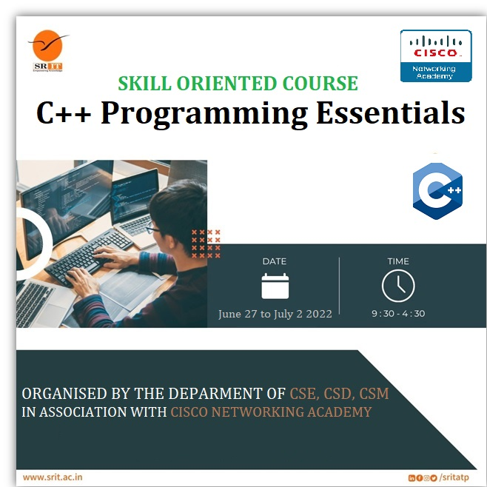

**e. Registered Students**

**II-II- CSD**

|  |  |  |
| --- | --- | --- |
| **S.NO** | **ROLL . NO** | **NAME OF THE STUDENT** |
| 1 | 204G1A3201 | ANJALI DEVI P |
| 2 | 204G1A3202 | ASHA K |
| 3 | 204G1A3203 | BHARATH R |
| 4 | 204G1A3204 | BHARGAVI P |
| 5 | 204G1A3205 | CHANDRA SHEKHAR K |
| 6 | 204G1A3206 | CHANDRAKALA K |
| 7 | 204G1A3207 | DEEPIKA D |
| 8 | 204G1A3208 | DEEPIKA REDDY B |
| 9 | 204G1A3209 | DIVYA SREE T |
| 10 | 204G1A3210 | GNANESWARI L |
| 11 | 204G1A3211 | GOWTHAMI A |
| 12 | 204G1A3212 | HARISH KUMAR G |
| 13 | 204G1A3213 | HARITHA K |
| 14 | 204G1A3214 | HARSHAD ALI M |
| 15 | 204G1A3215 | HARSHAVARDHAN P |
| 16 | 204G1A3216 | HARSHITHA J |
| 17 | 204G1A3217 | INDU T |
| 18 | 204G1A3218 | JAHNAVI S |
| 19 | 204G1A3219 | KASI REDDY K |
| 20 | 204G1A3220 | KRISHNA SAHITHI B |
| 21 | 204G1A3221 | LAIKHA FIRDOS S |
| 22 | 204G1A3222 | LAKSHMI NARAYANA E |
| 23 | 204G1A3223 | LATHA BAI H |
| 24 | 204G1A3224 | LAYA SREE B |
| 25 | 204G1A3225 | LEELA KRISHNA N |
| 26 | 204G1A3226 | LIKHITHA B |
| 27 | 204G1A3227 | LIKHITHA SRI P |
| 28 | 204G1A3228 | MADHAVA REDDY K |
| 29 | 204G1A3229 | MASARATH B S |
| 30 | 204G1A3230 | MEGHANA U |
| 31 | 204G1A3231 | MOHAMMED IMTHIYAZ S |
| 32 | 204G1A3232 | MUTHU D |
| 33 | 204G1A3233 | NARESH A |
| 34 | 204G1A3234 | NAVEED HUSSAIN B |
| 35 | 204G1A3235 | PARTHAVARDHAN YADAV K |
| 36 | 204G1A3236 | PAVAN P |
| 37 | 204G1A3237 | PAVANI D |
| 38 | 204G1A3238 | PAVANI KALYANI J |
| 39 | 204G1A3239 | PRASHANTH REDDY M |
| 40 | 204G1A3240 | PRAVALLIKA U |
| 41 | 204G1A3241 | PREM SAGAR H |
| 42 | 204G1A3242 | REKHA P |
| 43 | 204G1A3243 | RUPA LAKSHMI M |
| 44 | 204G1A3244 | SAI DINESH K |
| 45 | 204G1A3245 | SAI HARATHI P |
| 46 | 204G1A3246 | SAI RIKESH P |
| 47 | 204G1A3247 | SAI SREEJA M |
| 48 | 204G1A3248 | SAIF BABA M S |
| 49 | 204G1A3249 | SAMEER AHAMMAD S |
| 50 | 204G1A3250 | SHRESHA G |
| 51 | 204G1A3251 | SIVA SAI VIVEK S |
| 52 | 204G1A3252 | SREE KANTHI P |
| 53 | 204G1A3253 | SUJITHA P |
| 54 | 204G1A3254 | SULTAN MOHIUDDIN S |
| 55 | 204G1A3255 | SUMALATHA R |
| 56 | 204G1A3256 | SUNIL B |
| 57 | 204G1A3257 | TARUN KUMAR T |
| 58 | 204G1A3258 | TEJA SRI G |
| 59 | 204G1A3259 | UPENDRA REDDY M |
| 60 | 204G1A3260 | USHODAYA G |
| 61 | 204G1A3261 | VASAVI NEHA B |
| 62 | 204G1A3262 | VENKATA ANJANEYA REDDY D |
| 63 | 204G1A3263 | VENKATA SIVA DEEPAK REDDY R |
| 64 | 204G1A3264 | YATHEESH KUMAR REDDY K |
| 65 | 214G5A3201 | NARASIMHA G S |
| 66 | 214G5A3202 | PRABHAS A |
| 67 | 214G5A3203 | PRAVEEN REDDY Y |
| 68 | 214G5A3204 | SAI NIKHIL K |
| 69 | 214G5A3205 | SHAKEER C |
| 70 | 214G5A3206 | UDAY KIRAN D |

**f. Feedback Report**

**Event outcomes**

By completing the skill oriented course for one week, the candidate will be able to

1.Explain C++ fundamentals like variables, data types, operators, conditional and loop statements.

2. Use C++ compiler and its Standard libraries for input and output statements.

3.Implement object oriented featutures like class, constructor, inheritance, and polymorphism.

4.Use try, throw and catch key words for exceptional handling.

5.Construct overloading mechanisms like method overloading and operator overloading for a given class.

6.Construct object oriented frame work using generic class handling mechanism.

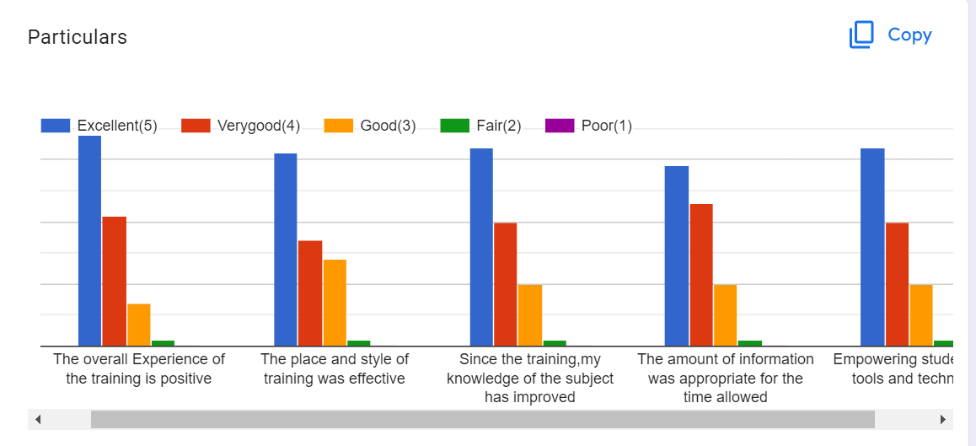

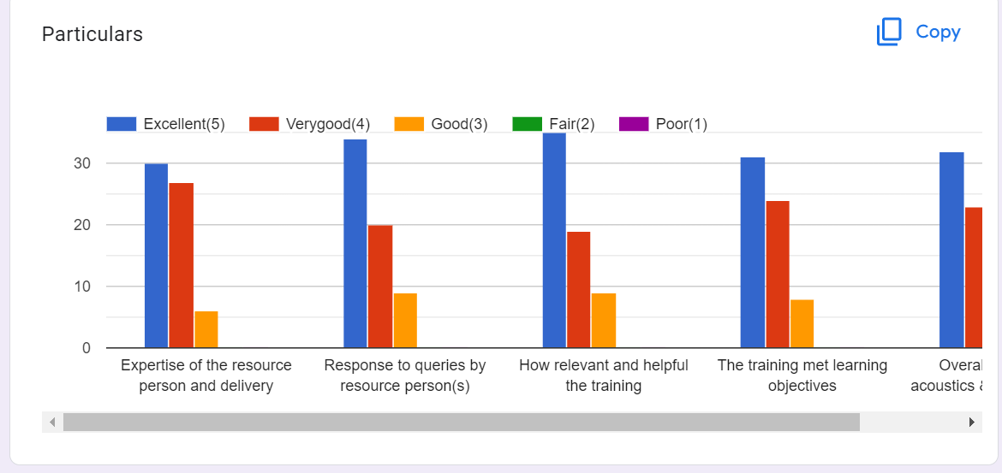

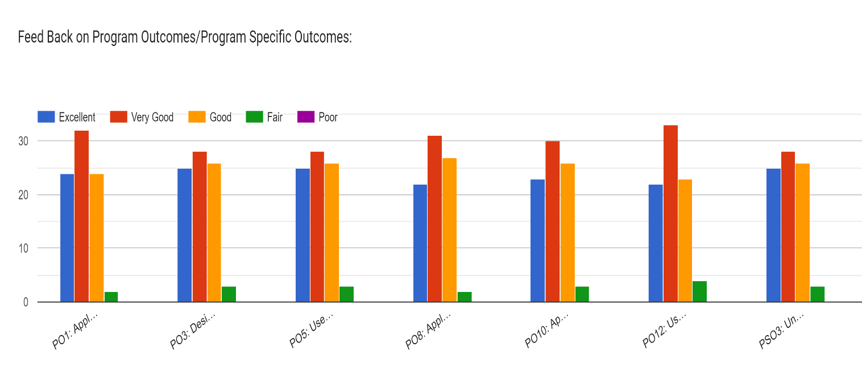

|  |  |  |  |  |  |  |  |  |  |  |  |  |  |  |  |
| --- | --- | --- | --- | --- | --- | --- | --- | --- | --- | --- | --- | --- | --- | --- | --- |
| **CO/PO** | **PO1** | **PO2** | **PO3** | **PO4** | **PO5** | **PO6** | **PO7** | **PO8** | **PO9** | **PO10** | **PO11** | **PO12** | **PSO1** | **PSO2** | **PSO3** |
| **CO1** | X |  |  |  | X |  |  |  |  |  |  |  | X |  |  |
| **CO2** | X |  | X |  | X |  |  |  |  |  |  |  | X |  |  |
| **CO3** | X |  | X |  | X |  |  |  |  |  |  |  | X |  |  |
| **CO4** | X |  | X |  | X |  |  |  |  |  |  |  | X |  |  |
| **CO5** | X |  | X |  | X |  |  |  |  |  |  |  | X |  |  |
| **CO6** | X |  | X |  | X |  |  |  | X |  |  |  | X |  |  |

Table 1: CO and PO Mapping for the event “C++ Programming Essentials”.

**g. Event Photos**

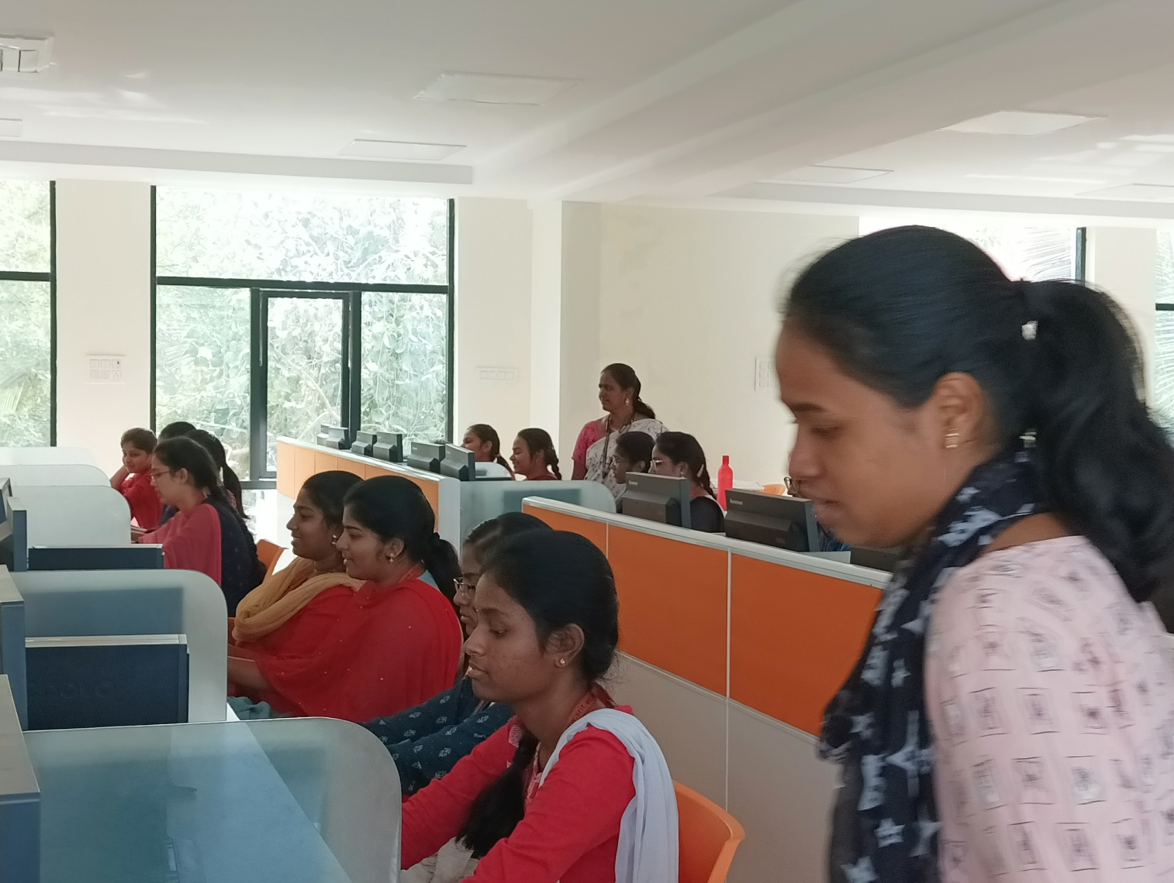

**Fig 1 :** G. Nagaleela Trainer demonstrating about C++ Programming Essentials

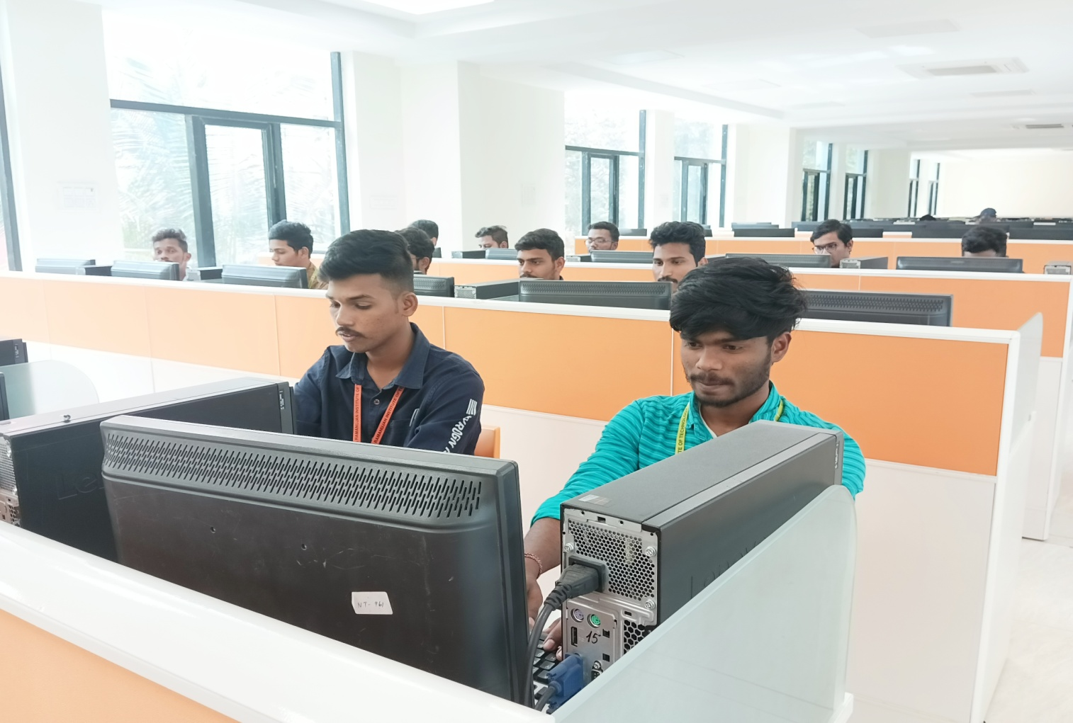

**Fig 2 :** Hands on Session of II CSD Students

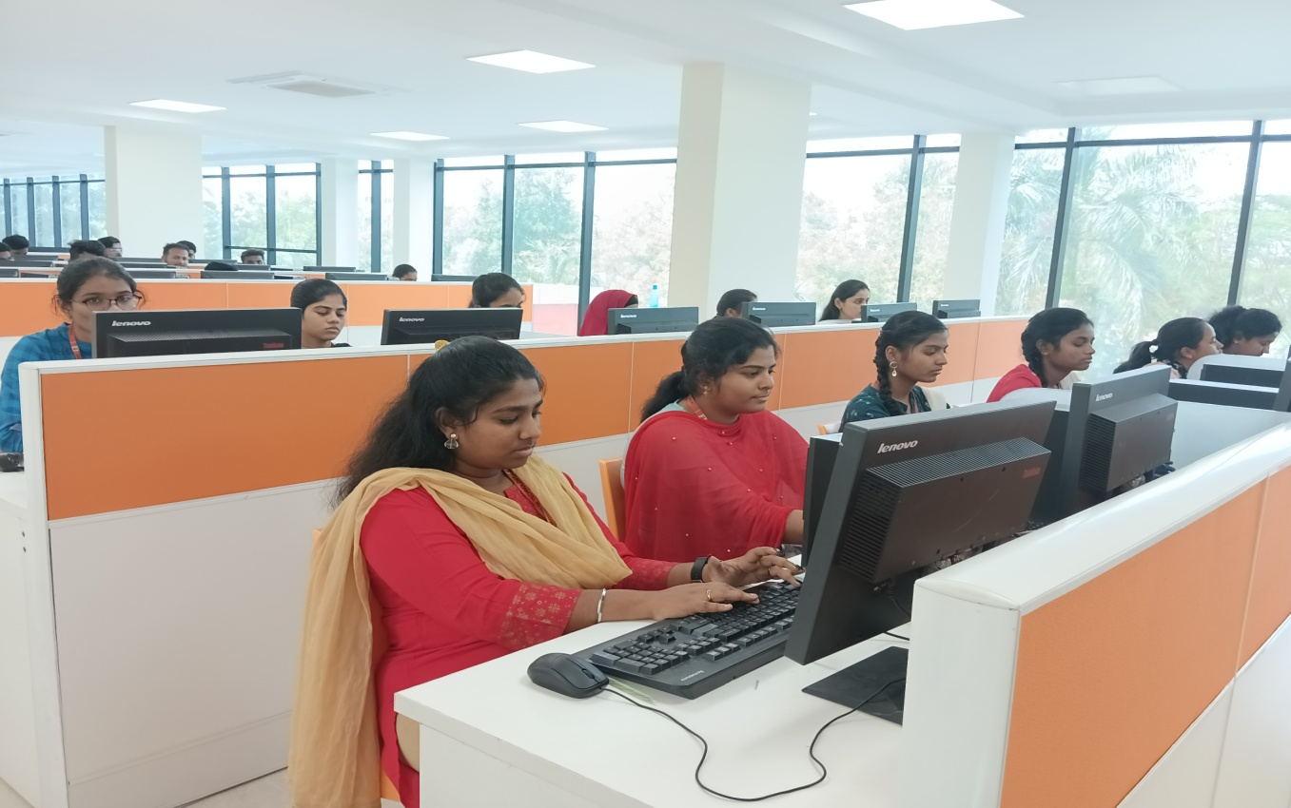

**Fig 3 :** Hands on Session of II CSD Students

